SULTAN QABOOS UNIVERSITY

College of Science Department of Computer Science

COMP3700: Introduction to Web Computing

Course Project: Part 3- JavaScript and Dynamic HTML

FitLlife Hub

**Team Members:**

Mohammed Yousuf Aljabri (132606)

Almuataz Alhadhrami (134812)

Alazhar Alabri (134783)

**Screenshots:**

1. **Matching Remember Game:** 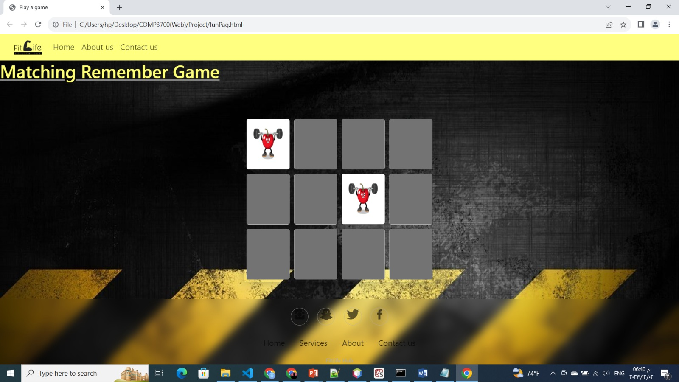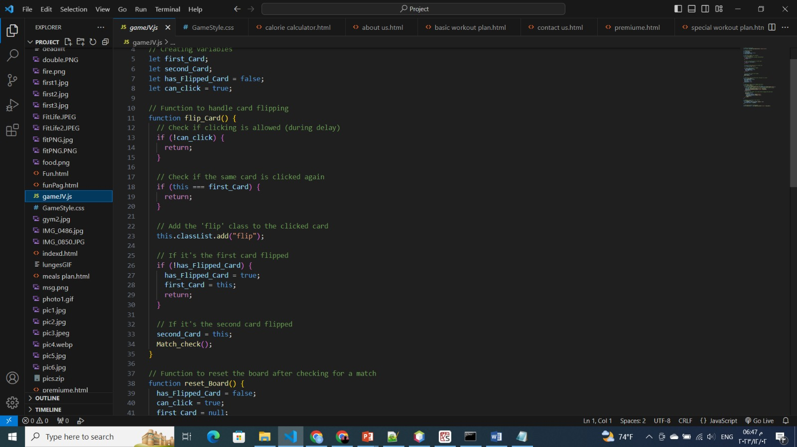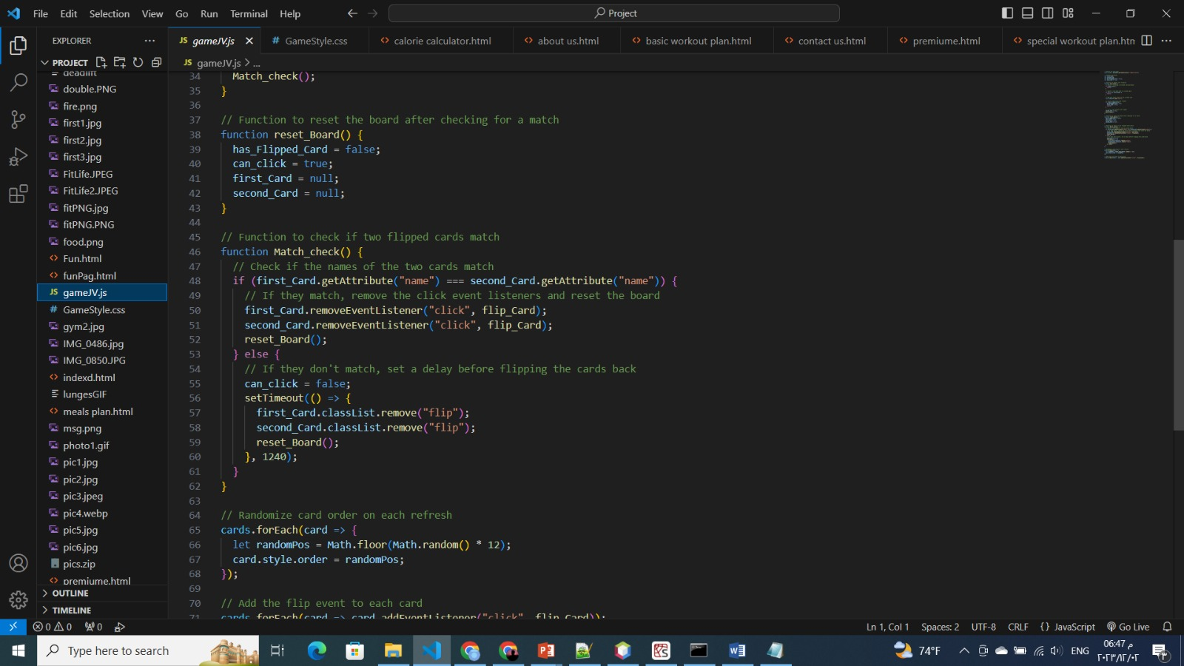

**-this game could have said as smart inelegant exercise.**

**- starting from the beginning we strake the code:**

**1-at a start we check if the user already clicked a card or not.**

**2-Next we call flip to the first card and then return.**

**3- complete with same steps but for the second card flipped and check both cards with function called Match_check() if both are equal.**

**4- the next step is to reset the game with function called reset_Board().**

**Function Match_check(){**

**Check the two names of the cards**

**Remove click event after checking returns true!**

**Call reset_Board()**

**If the two cards were not matched, put delay time before flipping the two cards.**

**Randomize all the cards and flip them to make it invisible.**

**2-Questionnaire page:**

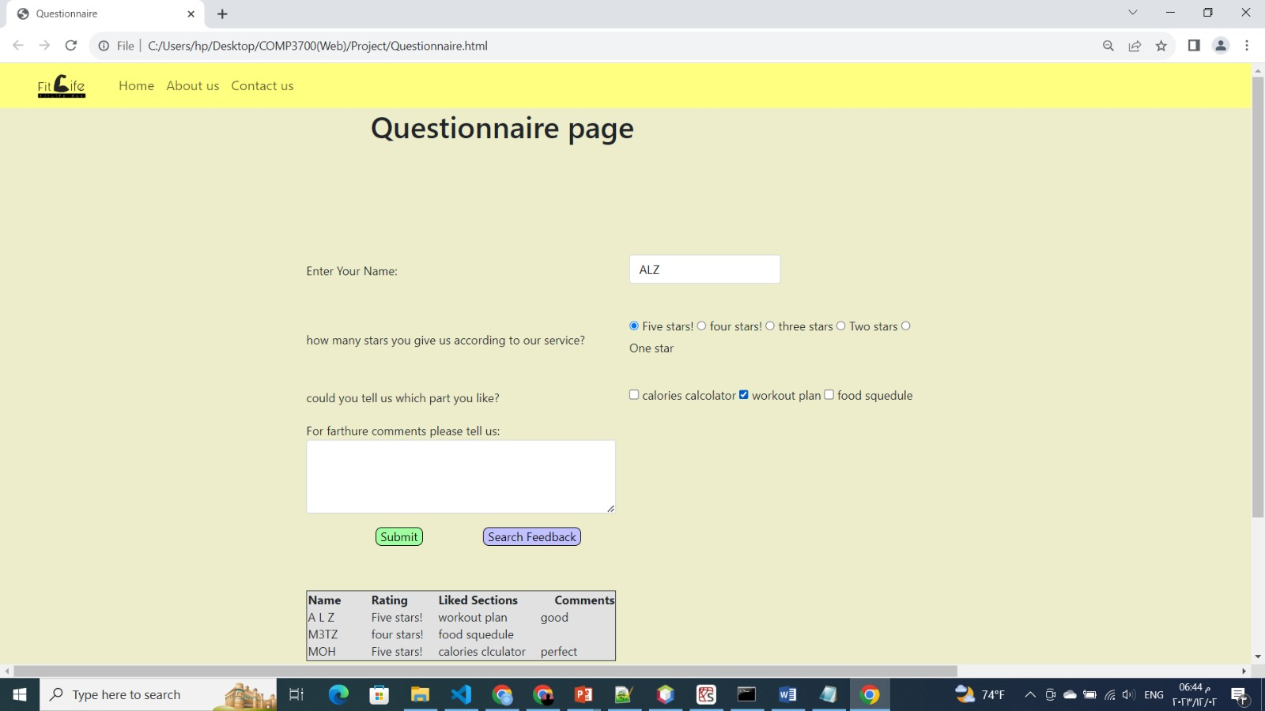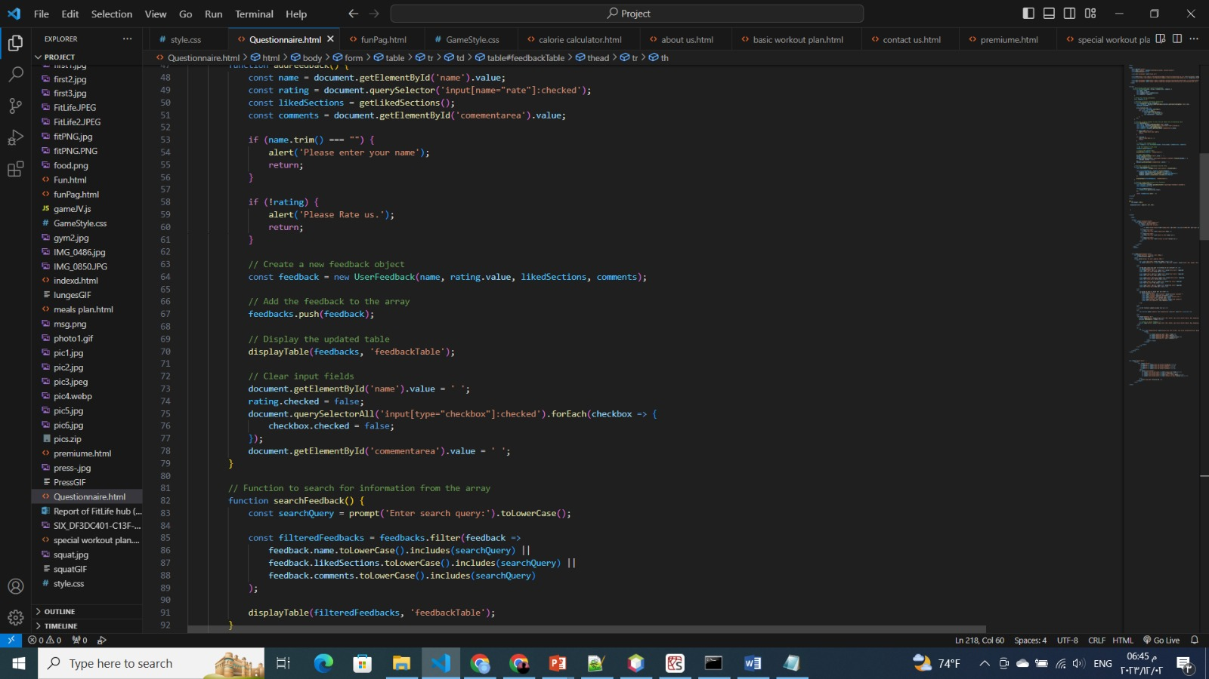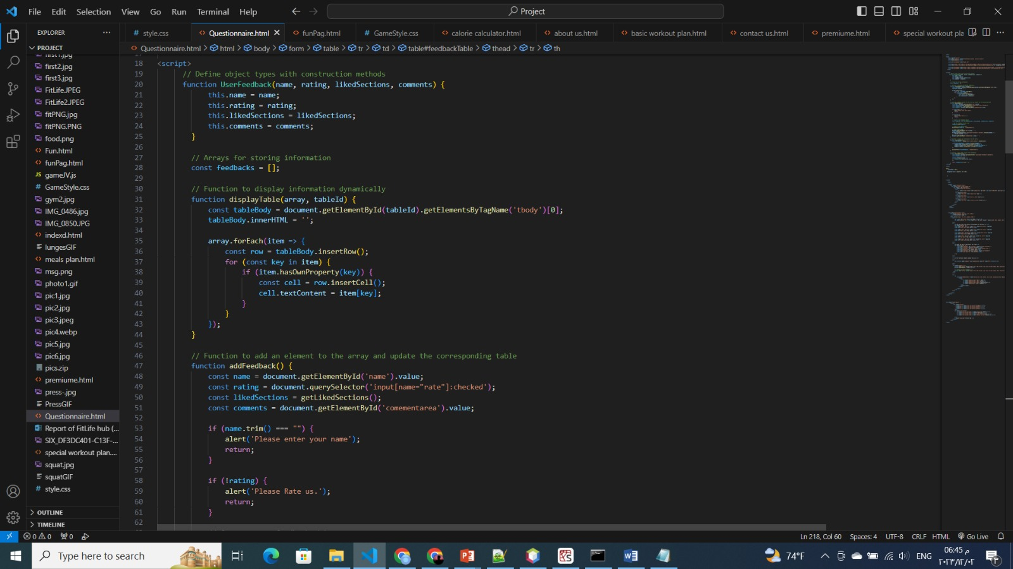

**-This page is for questionnaire users and visitors.**

**-create an array to save feedback info.**

**Function displayTable(array,tableId){**

**Inserting rows and cols to display the info in the page.}**

**Function addFeedback(){**

**-Save the data each type in a constructor and alert if one was not typed or answered.**

**-confirm and submit if all was answered and add it to the table to display it.}**

**Function searchFeedback(){**

**-this function purpose to search for queary in the array and display it}**

**3-calories calculator:**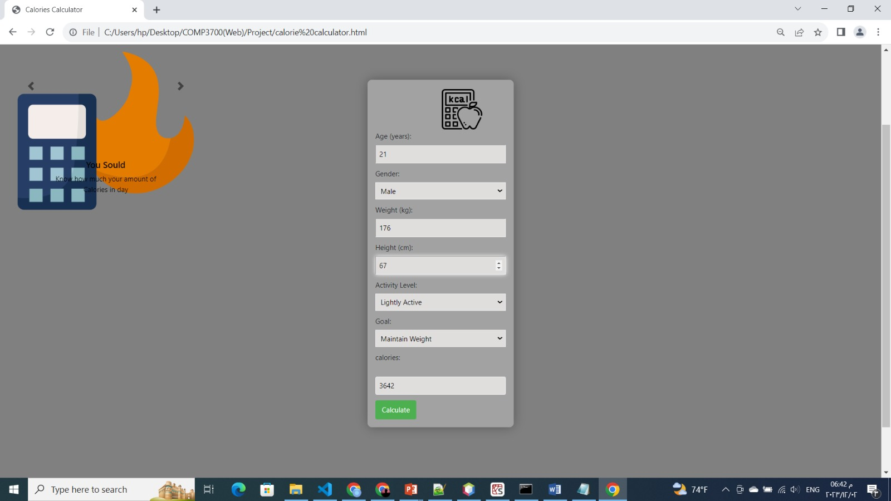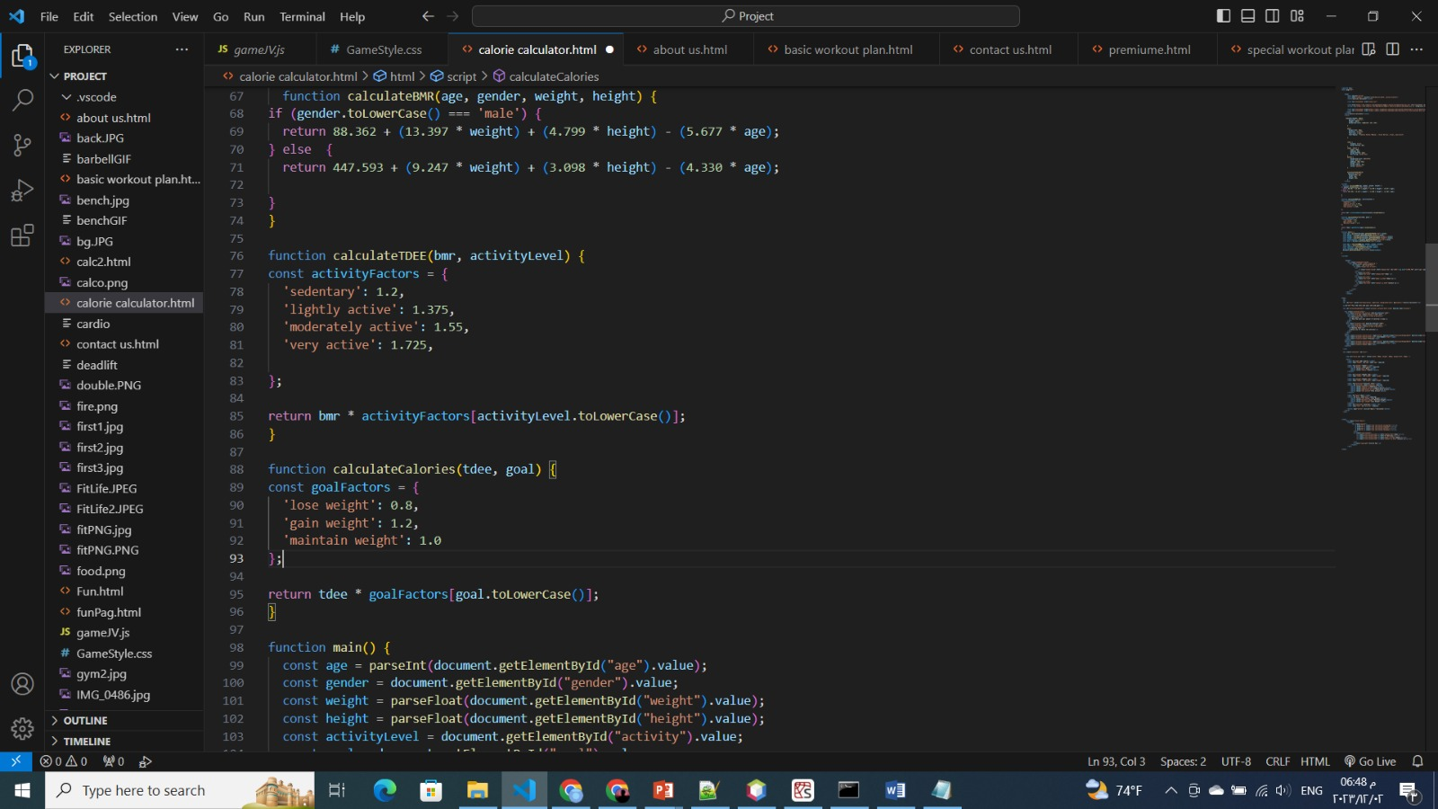

**-this page purpose is to calculate the calories according to the height and weight.**

**Function calculateTDEE{**

**Each type has its number of level and display it}**

**Function main(){**

**This page is for the rest of work we take the values by Id and save it.**

**The user will enter his info and calculate it and process until we reach the command calculate button.**

**Table:**

|  |  |  |
| --- | --- | --- |
| **Almuataz** | **Mohammed** | **Alazhar** |
| **Writing the first draft of the code as simple code written with full comments.** | **Modifying the code to be improved as well as matches the requirements.** | **Modify the pages with will designed and good look for the user and final check for the codes** |